Lab 2: Game Control with Joystick, Gyro and Accelerometer
EECE.5520 - Microprocessor II and Embedded System Design
Himadri Saha, Daniel Burns, Chris Worthley
Nov. 2, 2025

- General Information
Student Name: Daniel Burns
Student ID number: 01996432
Team Name/Number: Unknown
Team member names: Himadri Saha, Chris Worthley
Date of completion: 11/2/25
Demonstration method: zoom

Hardware Design
This project was far more software heavy than hardware. Since the majority of the program was given to us in the form of the snake game. The only real components needed in this lab was just the gyro sensor, and joystick. The only design elements we implemented were which GPIO pins we used from the Arduino and connected to the joystick and gyro sensor. The pins used for the joystick were A1 and A0, which are analog pins on the Arduino. This takes in the x, and y directions of the joystick, and uses it to find which direction the joystick is moving towards. The gyro sensor is using the I²C bus connection. The SDA (Serial Data) is connected to pin 20, while the SCL (Serial Clock) is connected to pin 21. Both of these components also use basic ground and VCC pins in order to power the sensors. There is no real circuit involved with this lab, only the two controller options. So, there are no real hardware designs other than the pin outs of the components.

Software Design
Our first iteration of our code was divided into 3 different programs. The first being the gyro tests file. This program was just a test for the gyro sensor, to see how the data was read in, along with how to use that data to determine direction. The second program was to test the loop and setup section of the code. The setup was used a serial begin command, and we used an LED to determine if it went through. The second part is the loop section. This section is really just a test for the serial available command. This allows the code to wait for available bytes to come in before it reads or writes the data in order to prevent errors. We tested this by outputting an LED high or low based on the output. Our final code combined all the parts and has four main stages of operation. This is shown in figure 1, where it shows the initial state being, with the setup phase. This state sets up the I²C bus and what device the data will be sent or stored to based on the address given. In our case the address was 0x68, which correlates to A0 when its tied to ground. Then prompts for an input on which way the user wants to control the snake whether it be using gyro tilt controls or using a joystick. The next state is the loop state. This state initially starts by probing for the input for which controller to be chosen. Then using that data continuously checks which style of controls that were selected. This is done using if statements to check for the probed variable “ch”. Depending on which number was given it would set up flag variable like, “modeSelected” and “controllerMode” so that the loop function doesn’t change the type of controller when looping. If neither is chosen, but rather the user inputs “E” then the buzzer class goes off, then sets the mode to the joystick controller automatically. Which finally leads to our last two states. These states depend on which controller is selected, but overall, they both control the same directions using different methods. Those directions are, up, down, left, and right. This is the final state, since the controls keep looping back within the loop state, and calls the controls over and over again allowing it to work properly and update every iteration. The joystick function, checks the deadzone value in comparison to the starting point to determine how far the joystick must move to determine the direction it moved. For the gyro sensor section, there is a similar solution. This being the tilt threshold in comparison with the converted g’s from the gyro’s data. The double points section was added by testing the acceleration of the gyro, and comparing it to the shake threshold, so we can determine how fast the gyro must move to activate double points. The code had many things to consider in its design. The first being the looping section of the code, allowing for updates and continuous use. The second was to increase the threshold values, making the sensors go off less, and decrease the chances of false inputs. The third large considerations we needed to make was to make this code around the Arduino IDE, where there is no main function, but rather a setup, and loop function. So we made the code to be looped continuously by the loop function and made like a main function that’s inside an infinite while loop.

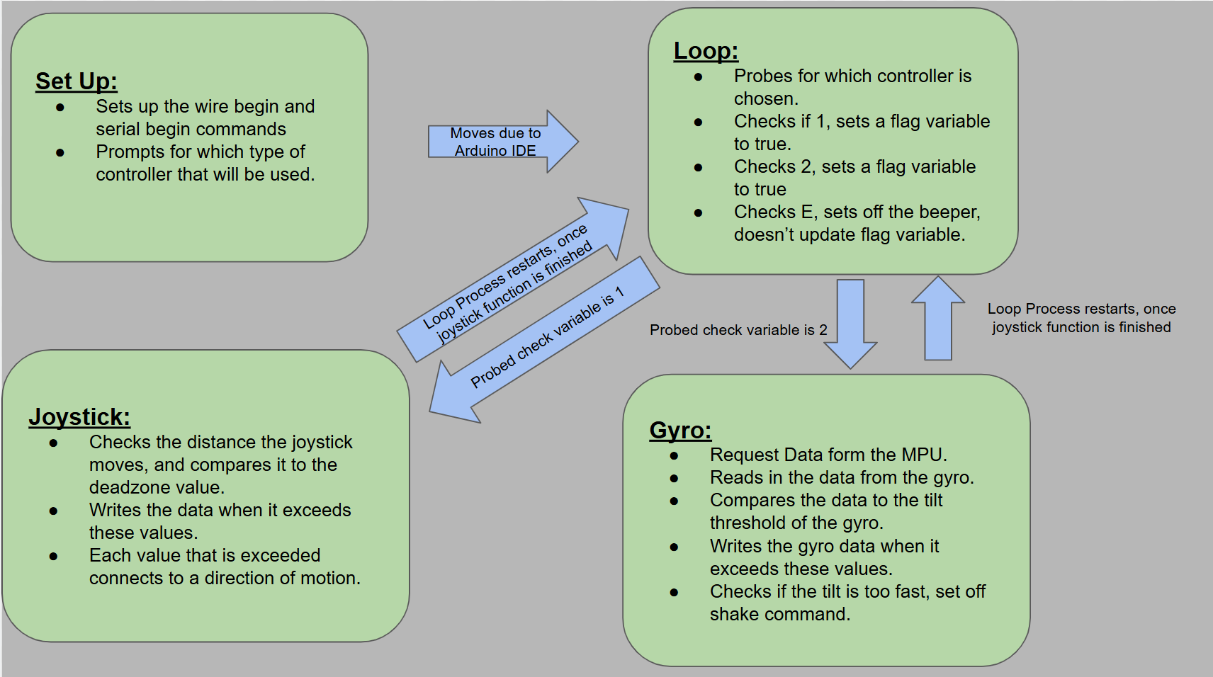
Figure 1. Flow Chart of our first Project Design
This image shows the initial design process for our code. This shows the 4 different states and what the states do in a general sense.

Results
In the end the lab worked exactly as assigned. We created a code that sets up an I²C bus to use the gyro sensor and save and write the data to be used. Then we successfully created a loop function to run through the whole program and differentiate between which controller to be used based on user input. There are two types of controllers, the gyro sensor, and joystick. The joystick was created using a dead zone variable, and the values read in by the analog pins A0 and A1. The joystick worked perfectly as shown in video 2, where the snake responds exactly in accordance with the joysticks movement. The gyro sensor was a little more complicated, using the I²C bus, we used 14 available bytes to read in the data for gyro. Using that data we create a range for each of the directions and accelerations. Using some threshold value, we got a working range for the gyro tilt and shaking. The tilt controls are demonstrated in video 1, where snake responds to whichever way the gyro was tilted towards. The shake is not demonstrated, but is still shown in the code, where the code writes a character “X” to the snake game code in order to set off the double points mode. Overall as mentioned in the beginning, lab 2 went as assigned without many issues or challenges along the way.
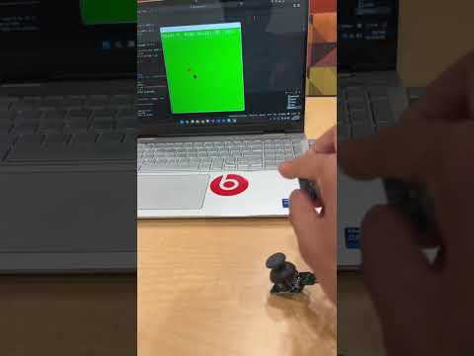
Video 1. Demonstration of Gyro Sensor
This image shows a basic demonstration of our gryro sensor and how the tilt was implemented. The video all shows how it outputs on the snake game.

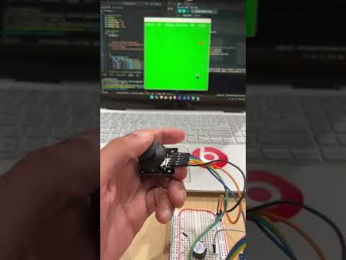
Video 2. Demonstration of Joystick
This video shows a similar situation to video 1, but changing controller type from gyro to joystick.

Problems Encountered and Solved
Overall, our lab went through pretty cleanly. We didn’t have too many problems and had a very solid idea, and understanding of the project from the beginning. However, towards the end stages of the lab, we experienced some instability errors. We had issues where the gyro sensor would go off sporadically and send the incorrect directions and signals to the game, along with this, the joysticks output was inverted. In order to solve the joystick problem, it was as simple as switching the signs on the comparing operators. This problem originally stemmed from a misunderstanding of the how the joysticks work, and how the Arduino reads in the data. It was a simple mistake with a simple solution. The second issue with the code had to do with the gyro instability. Originally, we made the gyro sensor too reactive to movement. So even a small movement would set the snake going in a certain direction. This appears to be sporadic, and instable, but the real issue was the sensitivity. This was fixed by increasing the tilt and shake threshold. So, the snake would only turn when an obvious motion is detected, rather than smaller minute movements. The shake threshold was also increased, so that the shake didn’t set itself off as a precaution. The final issue we encountered had to do with the com3 port. The connection was having issues and not working occasionally. But after a bit of trouble shooting we realized our issue, was that we kept forgetting to clear the port. Throughout this whole lab, we had minimal issues, and the few we did have were solved quickly and efficiently.

Personal Contribution - Himadri Saha
I was tasked to work on the hardware setup, and joystick controls functions for the Arduino. I created a couple test files. I did this to test how the joystick reads in data through the Arduino and how to use that data for the snake program in a controlled isolated environment. Using that file as reference, I was able to create a working joystick control function that used the commands from the premade python snake game. The second test file I made was for the set-up function. I created that function to test the serial commands. I specifically checked if I could use the serial available function to test if I could create an if statement that would wait until there were available bytes, before reading in new information. After making that test file I utilized it in the final code and put the controller deciding functions inside the available byte if statement. This was an important part of the loop function, as it allowed the “serial.read” function to work properly without errors. The final part of the lab I contributed were some final touches debugging and tuning the gyro sensors controls functions. I took some suggestions from Dan’s document on Github, while also using my own solutions. Overall, we found the same solutions to the problems. These problems being the sensors were too sensitive. Specifically, the tilt and shake threshold values, were too low, causing issues that were hard to read and understand. After a bit of debugging I pinpointed those issues and updated the values from 0.2 to 0.8 for the tilt threshold. Along with increasing the shake threshold from 25000 to 32800, in order to make sure that the shakes themselves don’t set off another shake and create an infinite shake loop.

Personal Contribution - Daniel Burns
I was tasked with overlooking the code while in its testing phase. I rewrote some code to fix the issues with certain issues. These Issues included inverted controls, and the gyro and joystick not responding properly in general. I researched this issue and came up with many possible solutions. The first being updating the tilt threshold to a higher value so that the tilting won’t go off when it doesn’t want to. I also suggested adding an if statement that reads in all bytes before running the joystick commands. This made sure all the data was available before running the read commands for the joystick. The next suggestion I made was to increase the shake sensitivity, so that the shaking doesn’t set itself off. The final issue I tried to solve was simple stability. I tried to solve this by adding delays at the end of each of the main processes. However, only two of these issues were uses in this code. The tilt threshold was raised from 0.2 to 0.8, and the shake threshold was raised from 25000 to 32800. Other than helping with troubleshooting, I wrote a majority of the report. Which includes the Hardware Design, Software Design, Results, Problems encounters, and lessons learned sections.

Personal Contribution - Chris Worthley
For Lab 2, my main contributions were focused on getting the MPU-6050 sensor system and hardware-software communication fully functional, as well as extending the game controls and debugging tools. I started by fixing and improving Himadri’s original gyro code, which wasn’t returning valid data from the MPU-6050. I rewrote the I2C initialization and data-read process inside the send_gyro_command() function to properly poll all 14 registers (accel + gyro) and convert them to usable float values in g’s and degrees/s. Once that was stable, I implemented the accelerometer functionality and wrote the shake detection logic, which checks if any of the GyX, GyY, or GyZ values exceed a defined SHAKE_THRESHOLD (32800). When that happens, the Arduino sends an 'X' flag over serial to the Python Snake game, causing the apple sprite to turn yellow and double in value the next time it’s eaten. I also fine-tuned the tilt control behavior by setting up direction thresholds (TILT_THRESHOLD = 0.8) so that the game responds smoothly to gyro movement without random drift.
Beyond sensor work, I added two-way serial communication between the Python game and the Arduino. I modified the loop to listen for an 'E' character from Python, which triggers the beep() function to pulse the buzzer whenever an apple is eaten or the player loses. I also developed a controller select system that lets the user toggle between joystick and gyro modes by sending '1' or '2' over serial, reflected through controllerMode and modeSelected flags. To make debugging easier, I implemented print statements for mode changes, which helped during testing.
Lessons Learned
Throughout this whole lab we learned two new components, and three new applications due to those components. The first new component we learned to work with is the joystick. In short, a joystick is essentially two potentiometers, one measured the x axis, the other measuring the y axis. The actual component takes two GPIO pins along with a ground and VCC leads. The GPIO pins were connected to A0 and A1, which are analog pins on the Arduino. The once of the new application we learned was the “analogread” function. This function takes in the analog data from the joystick and converts the voltage being measured into a range from 0 to 1023, basically converting an analog signal to digital. This range is then used in a simple comparison, to see if the joystick moved far enough to pass the dead zone. The second new component is the gyro sensor. This sensor also has an accelerometer inside with the gyroscope. The gyro sensor measures the change in tilt, whereas the accelerometer measures the acceleration of the sensor. With this new component, there are new application that we learned to use for this lab. That being the I²C bus. We created this bus in order to take in the digital data from the sensor and send that data to the code when requested, this is different from analog sensors, that measure data using a change in voltage. We took that data and converted the values taken in and converted them into g’s to be compared to the tilt and shake threshold values.

